**DESIGN DOCUMENT**

1. **Data flow diagram**

INTRANET CHATTING SERVICES

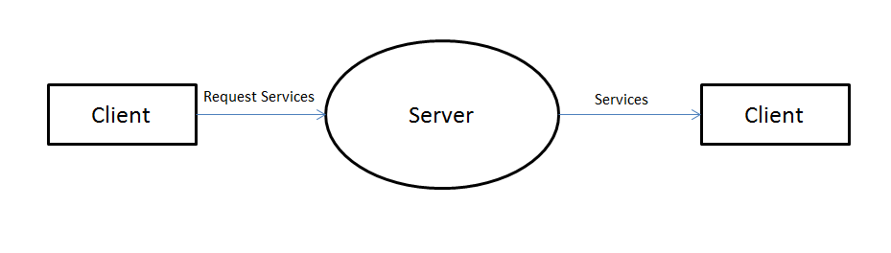

Client requests service to server and Server grants the request through a response to the client.

USER REGISTRATION 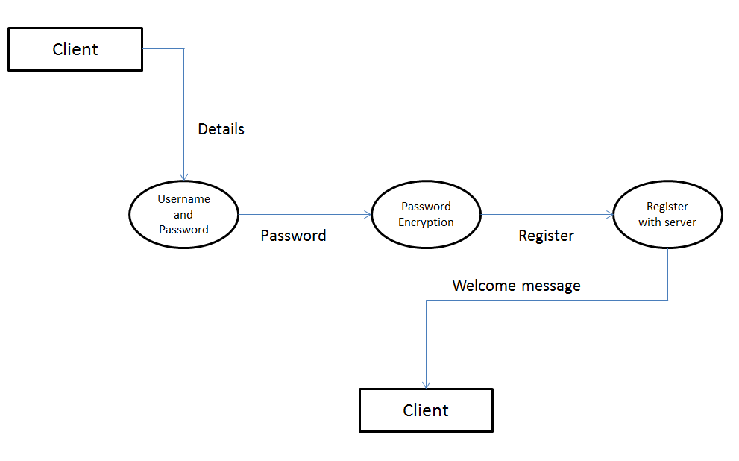

Client has to first register himself in the server to begin chatting. The client provides the server with unique id and password to log in.Server encrypts the PSWD and client is registered, welcome message prompted by server.

CHATTING

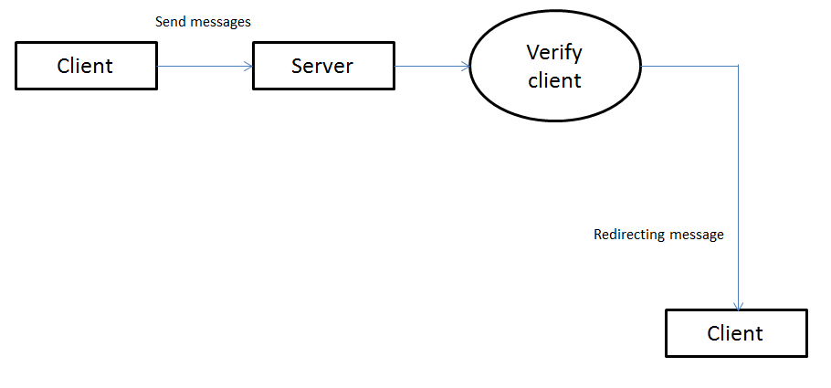

Client sends the message and that message is sent to Server and verify the receiver client and sends the message to receiver client.

LOGOUT

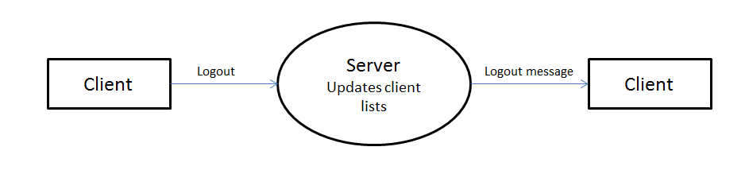

Client logs out of chat, server updates the list and send logout message to client.

1. **Use Case Diagram**

USER

SERVER

LOGIN

Validate information

Display List

LOG OUT

Manage account

Profile setting

Send broadcast messages

Chat with a contact

1. **Sequence Diagram**



**4.Block Diagram**

